CENWP-OD-B 05 June 2023

MEMORANDUM FOR THE RECORD

SUBJECT: 22BON025 MFR AFF Salmonid Mortality

On 05 June, Columbia River Inter-Tribal Fish Commission (CRITFC) Biologists notified Bonneville Project Biologists of one lamprey mortality found on the valve 15 trash rack in the Adult Fish Facility (AFF). The fish was scanned for PIT tags, inspected, and returned to the river.

- Species – Pacific Lamprey (Entosphenus tridentatus)
- Origin – Unknown
- Length – 71.12 cm
- Marks and tags – None
- Marks and Injuries found on carcass – Head contusion, bleeding from mouth
- Cause and Time of Death – Unknown
- Future and Preventative Measures – None
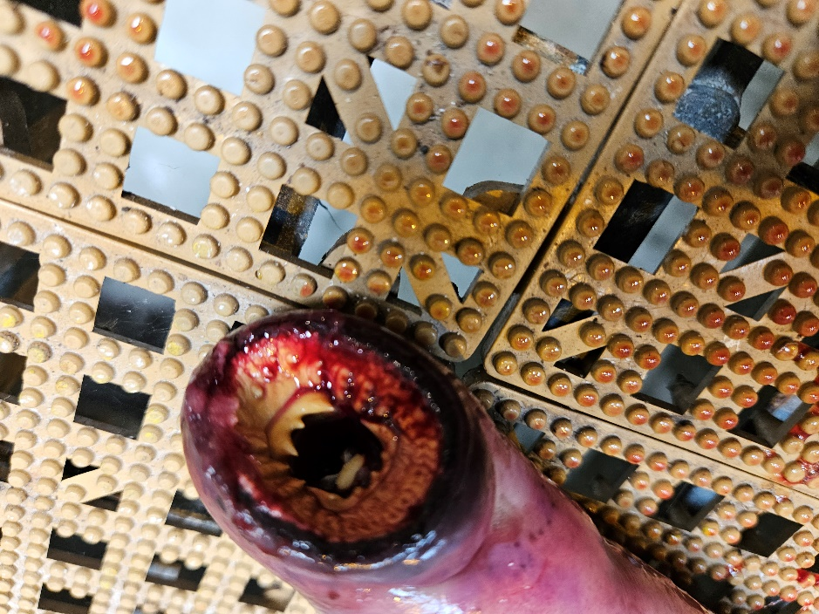
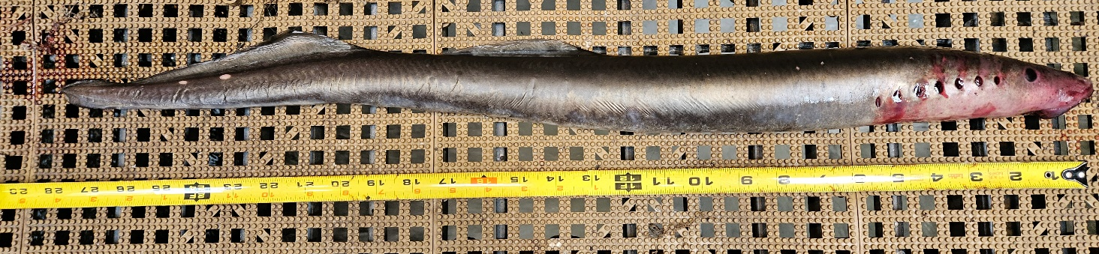

Sincerely,
Bonneville Project Fisheries

